Meno a priezvisko:
Škola: Bilingválne gymnázium C. S. Lewisa, Beňadická 38, Bratislava
Predmet: Fyzika
Školský rok/blok: /
Skupina:
Trieda:
Dátum:
Teória

Elektrické pole, magnetické pole, elektromagnetické pole
___________________________________________________________________________
Virtuálne experimenty a simulácie:
Electric Field of Dreams  Play ball! Add charges to the Field of Dreams and see how they react to the electric field. Turn on a background electric field and adjust the direction and magnitude.  Fyzika/Experimentation/gV_28/01_efield_en.jar  Sample Learning Goals  Explain the relation between the size and direction of the blue electric field lines to the sign and magnitude of the charge of a particle. Explain the interactions between two charged particles and explain why they move as they do. Explain what happens when you apply different external electric fields. | 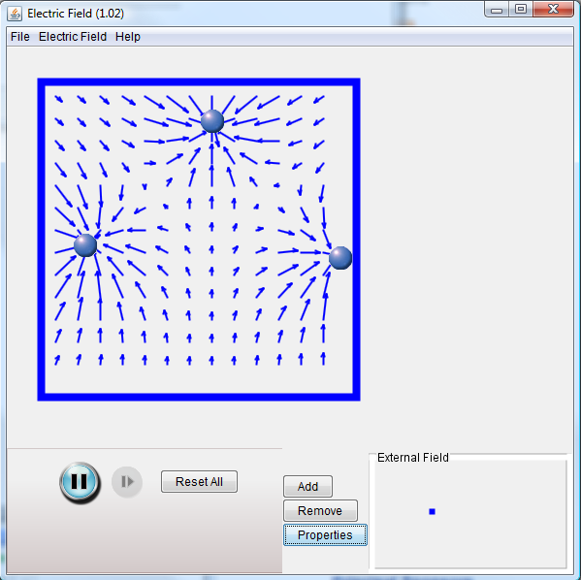
Charges and Fields  Move point charges around on the playing field and then view the electric field, voltages, equipotential lines, and more.  Umiestnite bodové náboje na plochu a potom sledujte elektrické pole znázornené intenzitou elektrického pola, elektrickým potenciálom a ekvipotenciálnymi hladinami.  Fyzika/Experimentation/gV_28/02_charges-and-fields_sk.jar  Sample Learning Goals  Determine the variables that affect how charged bodies interact. Predict how charged bodies will interact. Describe the strength and direction of the electric field around a charged body. Use free-body diagrams and vector addition to help explain the interactions. | 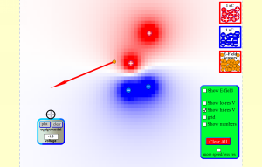
Electric Field Hockey  Play hockey with electric charges. Place charges on the ice, then hit start to try to get the puck in the goal. View the electric field. Trace the puck's motion. Make the game harder by placing walls in front of the goal. This is a clone of the popular simulation of the same name marketed by Physics Academic Software and written by Prof. Ruth Chabay of the Dept of Physics at North Carolina State University.  Zahrajte si hokej s elektrickým nábojom. Umiestnite na ľad elektrické náboje tak, aby sa puk dostal do bránky. Môžete tiež zobraziť elektrické pole a trajektóriu puku. Ak umiestnite pred bránku prekážky, tak dať gól bude dosť ťažké, ale je to možné.  Fyzika/Experimentation/gV_28/03_electric-hockey_sk.jar  Sample Learning Goals  Determine the variables that affect how charged bodies interact. Predict how charged bodies will interact. Describe the strength and direction of the electric field around a charged body. Use free-body diagrams and vector addition to help explain the interactions. | 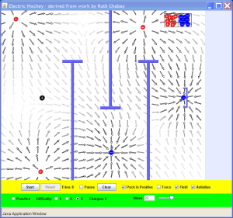
Balloons and Static Electricity  Why does a balloon stick to your sweater? Rub a balloon on a sweater, then let go of the balloon and it flies over and sticks to the sweater. View the charges in the sweater, balloons, and the wall.  Prečo sa balón prichytí váš sveter? Pošúchajte balón o sveter, vzdiaľte ho od svetra a pustite ho. Balón opäť priletí k svetru. Priložte balón k múru a oň zostane na ňom prichytený. Prečo? Všimnite si elektrický náboj na svetri, balóne a múre.  Fyzika/Experimentation/gV_28/04_balloons_sk.jar  Sample Learning Goals  Describe and draw models for common static electricity concepts (transfer of charge induction attraction repulsion and grounding) | 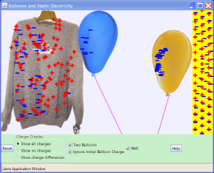
John Travoltage  Make sparks fly with John Travoltage. Wiggle Johnnie's foot and he picks up charges from the carpet. Bring his hand close to the door knob and get rid of the excess charge.  John Travolt alias John Napäťový môže byť zdrojom elektrickej iskry. Šúchaním jeho topánky po koberci sa z koberca premiestni elektrický náboj na jeho telo. Ak chytí rukou kľučku dverí, tak preskočí elektrická iskra. Skúmajte na akú vzdialenosť sa musí priblížiť ku kľučke, aby preskočila iskra. Je tá vzdialenosť vždy rovnaká a ak nie, tak od čoho závisí?  Fyzika/Experimentation/gV_28/05_travoltage_sk.jar  Sample Learning Goals  Describe and draw models for common static electricity concepts. (transfer of charge induction attraction repulsion and grounding) | 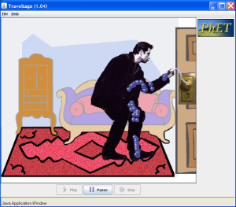
Magnet and Compass  Ever wonder how a compass worked to point you to the Arctic? Explore the interactions between a compass and bar magnet, and then add the earth and find the surprising answer! Vary the magnet's strength, and see how things change both inside and outside. Use the field meter to measure how the magnetic field changes.  Ste zvedaví prečo kompas ukazuje vždy na severný pól ? Preskúmajte vzájomné pôsobenie kompasu a tyčového magnetu a potom kompasu a Zeme. Meňte magnetickú intenzitu a sledujte ako sa mení situácia okolo magnetu.  Fyzika/Experimentation/gV_28/06_magnet-and-compass_sk.jar  Sample Learning Goals  Predict the direction of the magnet field for different locations around a bar magnet Relate magnetic field strength to distance quantitatively and qualitatively Describe how the earth's magnet field relates to a bar magnet | 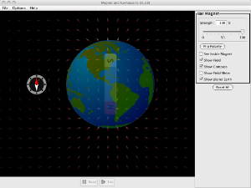
Magnets and Electromagnets  Explore the interactions between a compass and bar magnet. Discover how you can use a battery and wire to make a magnet! Can you make it a stronger magnet? Can you make the magnetic field reverse?  Hraním s tyčovým magnetom a elektrickým vinutím sa naučte princíp Faradayovho zákona. Pohybom magnetu v blízkosti elektrického vinutia rozsvieťte žiarovku. Všimnite si znázornenie magnetického poľa indukčnými čiarami. Meracím prístrojom môžete určiť magnetickú indukciu v rôznych bodoch poľa. Môžete tiež sledovať funkciu transformátora alebo generátora na výrobu elektrickej energie.  Fyzika/Experimentation/gV_28/07_magnets-and-electromagnets_sk.jar  Sample Learning Goals  Predict the direction of the magnet field for different locations around a bar magnet and electromagnet Compare and contrast bar magnets and electromagnets Identify the characteristics of electromagnets that are variable and what effects each variable has on the magnetic field's strength and direction Relate magnetic field strength to distance quantitatively and qualitatively | 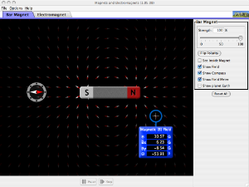
Generator  Generate electricity with a bar magnet! Discover the physics behind the phenomena by exploring magnets and how you can use them to make a bulb light.  Hraním s tyčovým magnetom a elektrickým vinutím sa naučte princíp Faradayovho zákona. Pohybom magnetu v blízkosti elektrického vinutia rozsvieťte žiarovku. Všimnite si znázornenie magnetického poľa indukčnými čiarami. Meracím prístrojom môžete určiť magnetickú indukciu v rôznych bodoch poľa. Môžete tiež sledovať funkciu transformátora alebo generátora na výrobu elektrickej energie.  Fyzika/Experimentation/gV_28/08_generator_sk.jar  Sample Learning Goals  Identify equipment and conditions that produce induction Compare and contrast how both a light bulb and voltmeter can be used to show characteristics of the induced current Predict how the current will change when the conditions are varied. Explain practical applications of Faraday's Law Explain what is the cause of the induction | 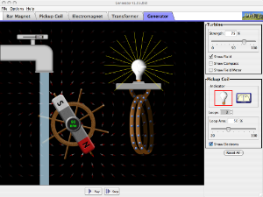
Radio Waves & Electromagnetic Fields  Broadcast radio waves from KPhET. Wiggle the transmitter electron manually or have it oscillate automatically. Display the field as a curve or vectors. The strip chart shows the electron positions at the transmitter and at the receiver.  Fyzika/Experimentation/gV_28/09_radio-waves_sk.jar  Rozhlasové vlny sa šíria od vysielača. Elektróny v anténe vysielača môžete rozkmitať ručne alebo automaticky oscilátorom. Šírenie elektromagnetického vlnenia môžete znázorniť pomocou vlny alebo vektorov elektrického poľa. Čiarový graf vám ukáže zmenu polohy elektrónu v anténe vysielača a prijímača. | 